

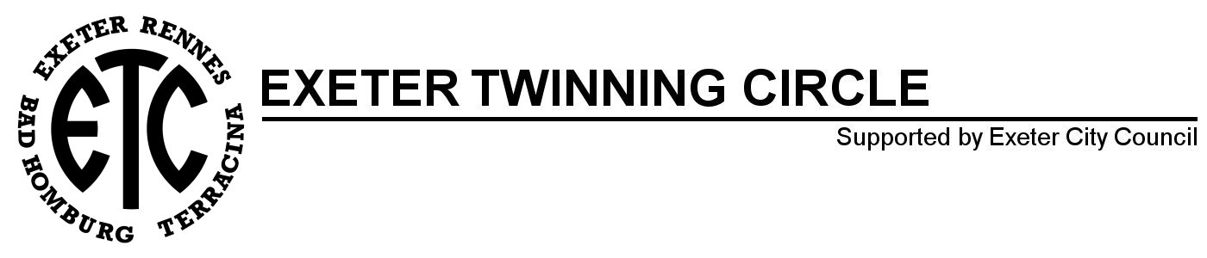



EXETER TWINNING CIRCLE SIGNS PARTNERSHIP AGREEMENT WITH BRITTANY FERRIES

As of January 2026 members will benefit from the following discounts:

10% discount for your members' family trips, outside of the exchanges organised by the Twinning Committee, with their vehicle or on foot (Excluding on board accommodation).

5% discount on the public rate for the Twinning Committee's foot passenger trips (from 10 or more people, excluding on board accommodation).

10% discount on the public group rate for the Twinning Committee's trips by coach. (Excluding on board accommodation).

For information on how to access the discount for members’ family trips please contact the secretary.




